**Attendance Management System Using Face Recognition**

A Project Report

submitted in partial fulfillment of the requirements

of

AICTE Internship on AI: Transformative Learning

with

TechSaksham – A joint CSR initiative of Microsoft & SAP

by

**Bontha Vennela , vennelabontha809@gmail.com**

Under the Guidance of

Aditya Prashant Ardhak

Master Trainer , Edunet Foundation.

**ACKNOWLEDGEMENT**

We would like to express our sincere gratitude to everyone who contributed to the successful completion of Attendance Management System by using Face Recognition project. We extend our deepest appreciation to our guide, Aditya Prashant Ardak (Master Trainer , Edunet Foundation) , for their invaluable support, insightful feedback, and continuous encouragement throughout the development of this system. Their guidance has been instrumental in refining our ideas and achieving our research goals.

We are also thankful to Dr .Thejovathifor providing the necessary resources and facilities to conduct this research. Additionally, we would like to thank our my classmates for their constructive discussions and suggestions, which helped improve the quality of our work.

Finally, we are grateful to our families and friends for their unwavering support and encouragement during this endeavor.

#### **ABSTRACT**

In educational institutions and organizations, traditional attendance management methods are often inefficient, time-consuming, and prone to errors or proxy attendance. This paper presents a face recognition-based attendance management system that automates and streamlines the attendance process. The system leverages computer vision and deep learning techniques to accurately detect and recognize faces in real-time using a camera feed. The proposed system integrates **Convolutional Neural Networks (CNNs)** for face recognition and **Haar Cascade classifiers** for face detection. The attendance is recorded automatically by matching detected faces against a pre-existing database, ensuring high accuracy and eliminating manual intervention.

The system features a **user-friendly interface**, database management, and real-time processing capabilities. Experiments conducted demonstrate that the system achieves reliable performance under varying lighting conditions and different facial orientations. This solution enhances efficiency, security, and accuracy while addressing issues such as identity fraud and attendance manipulation. The proposed system can be seamlessly integrated into existing infrastructures in schools, colleges, and corporate environments to simplify attendance management.

**TABLE OF CONTENT**

**Abstract** **3**

**Chapter 1.**  **Introduction 1**

1.1 Problem Statement 1

1.2 Motivation 1

1.3 Objectives 2

1.4. Scope of the Project 2

**Chapter 2.**  **Literature Survey 3**

**Chapter 3.**  **Proposed Methodology**

**Chapter 4.**  **Implementation and Results**

**Chapter 5. Discussion and Conclusion**

**LIST OF FIGURES**

|  |  |  |
| --- | --- | --- |
| **Figure No.** | **Figure Caption** | **Page No.** |
|  | Problem Statement | **5** |
|  | Architecture | **8** |
|  | Software Requirement | **13** |
|  | Image Processing | **18** |

**LIST OF TABLES**

|  |  |  |
| --- | --- | --- |
| **Table. No.** | **Table Caption** | **Page No.** |
| **1** | Problem Statement | **7** |
| **2** | Motivation | **8** |
| **3** | Objective | **10** |
| **4** | Scope Of the Project | **12** |
| **5** | Literature Survey | **13** |
| **6** | System Design | **14** |
| **7** | Implementation & Results | **161** |
| **8** | Discussion & Conclusion | **18** |
| **9** | Reference | **20** |

**CHAPTER 1**

**Introduction**

* 1. **Problem Statement:**

Traditional attendance management methods, such as manual roll calls, sign-in sheets, or ID-based systems, are inefficient, time-consuming, and prone to errors. These methods are susceptible to issues like **proxy attendance (buddy punching), manual entry errors, and lost records**. Additionally, as class sizes and organizational workforces grow, these methods become increasingly cumbersome and difficult to manage.

Inaccurate attendance records can lead to compromised academic integrity, unreliable performance assessments, and challenges in workforce management. For educational institutions, this can affect student performance tracking, while for organizations, it can lead to payroll inaccuracies and reduced productivity.

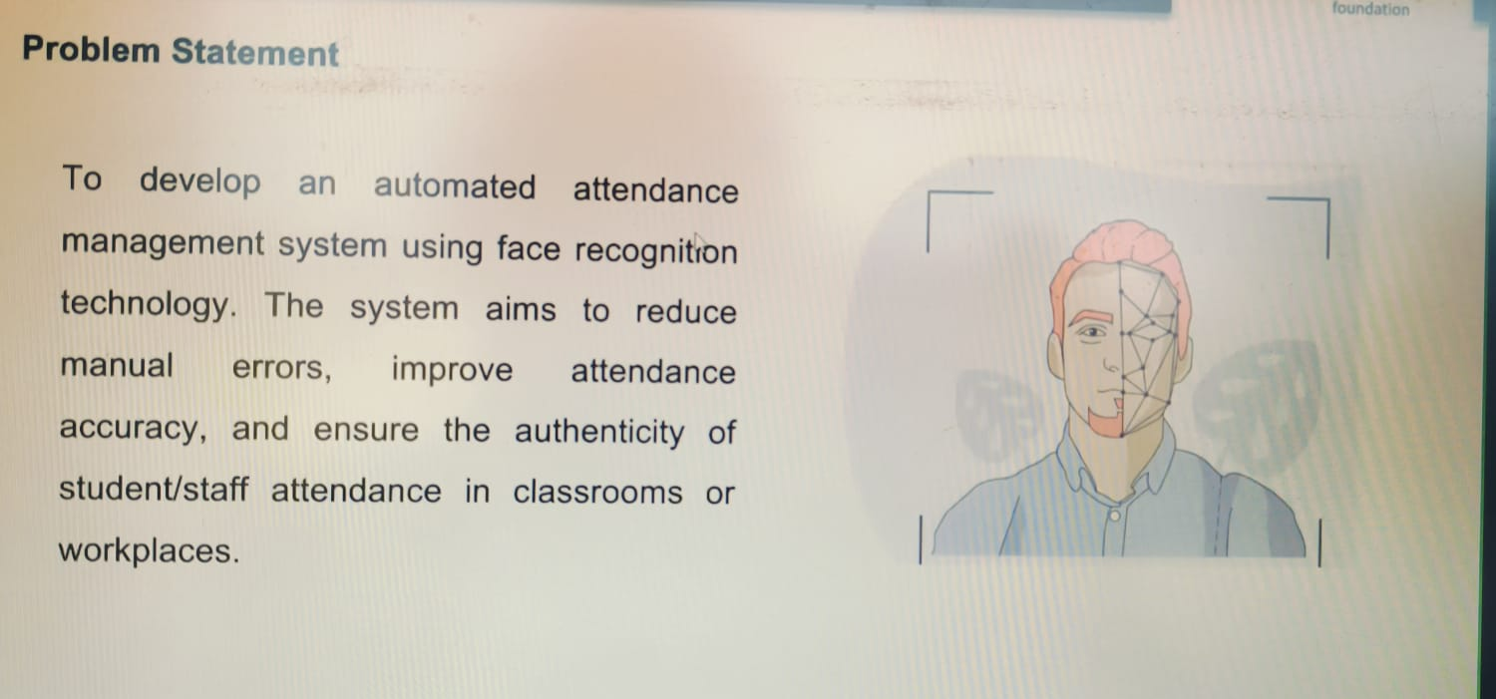

* 1. **Motivation:**   
     This project was chosen to address the limitations and inefficiencies of traditional attendance management methods in educational institutions, workplaces, and other organizational settings. The increasing adoption of digital transformation and biometric technologies has created an opportunity to improve legacy systems. Face recognition technology offers a promising solution due to its ability to automate processes while ensuring accuracy, security, and ease of use. Additionally, advancements in computer vision and deep learning have made face recognition more reliable, accessible, and cost-effective, making this the right time to implement such solutions.

The motivation for this project stems from the need to:

* **Eliminate proxy attendance** (buddy punching).
* **Streamline attendance processes** in large classrooms or workplaces.
* **Reduce administrative workload** related to manual record-keeping.
* **Leverage modern AI technologies** to solve real-world problems efficiently.
* **Increased Efficiency:**
* Automating attendance processes reduces administrative burdens and saves time, allowing educators, managers, and administrators to focus on more critical tasks.
* **Enhanced Security and Integrity:**

Biometric verification ensures accurate identification, significantly reducing the chances of fraud and proxy attendance.

* **Improved Data Management:**

Centralized, real-time attendance records provide valuable insights into attendance patterns, allowing for better decision-making and reporting.

* **Scalability and Adaptability:**

The system can easily scale to accommodate growing class sizes or expanding organizations, making it a versatile solution for various environments.

* **Cost-Effective in the Long Run:**

Although initial implementation may require investment, the system reduces long-term costs associated with manual labor, errors, and fraud-related issues.

* **Positive User Experience:**

Touchless attendance methods improve hygiene and convenience, particularly relevant in the post-pandemic world.

**1.3Objective:**

The primary objective of this project is to design and implement an **Attendance Management System Using Face Recognition** that automates attendance tracking and addresses the limitations of traditional methods. The specific objectives are as follows:

**Automate Attendance Recording:**

* Develop a system capable of automatically capturing and recording attendance through face recognition, eliminating the need for manual roll calls or sign-ins.

**Ensure Accuracy and Reliability:**

Utilize advanced face recognition algorithms to achieve a high level of accuracy in detecting and identifying individuals, reducing errors and minimizing false positives/negatives.

**Prevent Proxy Attendance:**

Implement biometric verification to prevent proxy attendance (buddy punching), ensuring that only the authorized person can mark their attendance.

**Provide Real-Time Processing and Updates:**

Design the system to process and update attendance records in real time, allowing administrators immediate access to attendance data.

**Create a User-Friendly Interface:**

Develop an intuitive and easy-to-use interface for administrators, teachers, and users, ensuring seamless interaction with the system.

**Enable Centralized Data Storage:**

Integrate a database to securely store attendance records, ensuring data integrity, easy retrieval, and efficient reporting.

**Ensure Scalability and Flexibility:**

Design the system to be scalable for use in various environments, such as classrooms, offices, and large events, accommodating an increasing number of users.

**Facilitate Reporting and Analytics:**

Provide functionality for generating attendance reports and analyzing attendance patterns to support decision-making and performance monitoring.

**Optimize Performance Under Various Conditions:**

Ensure that the system performs reliably under different lighting conditions, facial orientations, and environments to improve robustness.

**Enhance Security and Privacy:**

Implement security measures to protect biometric data and user privacy, complying with relevant data protection standards and best practices.

**1.4 Scope of the Project:**

1. **Automated Attendance Management:**

The system automates the process of recording attendance through face recognition, replacing traditional manual methods such as roll calls or sign-in sheets.

1. **Face Recognition Technology:**

Utilizes advanced computer vision techniques and deep learning models (e.g., Convolutional Neural Networks) to detect and recognize faces in real time.

1. **Database Integration:**

A centralized database will be used to store user details (such as names, IDs, and face data) and attendance records for easy retrieval, analysis, and reporting.

1. **User Authentication:**

Each user’s attendance will be verified through biometric face recognition to prevent proxy attendance or fraud.

1. **Real-Time Processing:**

The system will process attendance records in real time, providing immediate updates and generating attendance reports on demand.

1. **User-Friendly Interface:**

The system will offer an intuitive interface for administrators, teachers, or HR personnel to manage attendance data and monitor attendance trends.

1. **Scalability:**

Designed to handle large numbers of users, making it applicable to educational institutions, corporate offices, events, and other environments.

**CHAPTER 2**

**Literature Survey**

1. **Face Detection and Recognition Algorithms:**

* **Traditional Methods:**
  + Haar Cascade Classifiers: A popular technique for detecting facial features in real-time, often used in conjunction with other methods for recognition.

[Face Detection with Haar Cascade. Exploring a bit older algorithm which… | by Girija Shankar Behera | Towards Data Science](https://towardsdatascience.com/face-detection-with-haar-cascade-727f68dafd08)

* Local Binary Patterns (LBP): A texture descriptor used for face recognition, which is robust to variations in illumination and facial expressions.

[Face Recognition with Local Binary Patterns (LBPs) and OpenCV - PyImageSearch](https://pyimagesearch.com/2021/05/03/face-recognition-with-local-binary-patterns-lbps-and-opencv/#:~:text=In%20this%20tutorial%2C%20you%20will,face.)

1. **Deep Learning Approaches:**

* Convolutional Neural Networks (CNNs): State-of-the-art for face recognition, capable of learning complex features from large datasets.Models like VGG, ResNet, and Facenet have shown excellent performance.

[Face Recognition using FaceNet (Survey, Performance Test, and Comparison) | Semantic Scholar](https://www.semanticscholar.org/paper/Face-Recognition-using-FaceNet-(Survey%2C-Performance-William-Setiadi/c3c42f144b36f5f851b2629ef71e4b50300f9003)

1. **Siamese Networks:**

A type of neural network architecture specifically designed for similarity learning, making it suitable for face verification and recognition tasks.

[Deep Learning Based Face Recognition Method using Siamese Network](https://arxiv.org/html/2312.14001v2#:~:text=In%20summary%2C%20our%20proposed%20siamese,classification%20decisions%20with%20respect%20to)

1. **Face Recognition-Based Attendance System Using Deep Learning:**

This paper proposes a system that leverages a pre-trained deep learning model (e.g., VGG-Face) for face recognition, combined with a Haar Cascade classifier for face detection. The system demonstrates high accuracy and efficiency in real-time attendance management.

[(PDF) Face Recognition based Attendance Management System](https://www.researchgate.net/publication/341876647_Face_Recognition_based_Attendance_Management_System#:~:text=This%20research%20project%20utilizes%20image,streamline%20the%20attendance%2Dtaking%20process.)

**5)Real-Time Face Recognition for Attendance Management:**

This research focuses on real-time implementation, utilizing a lightweight CNN model and optimized inference techniques to achieve fast and accurate face recognition.

6)**Secure and Privacy-Preserving Face Recognition for Attendance Systems:**

This paper addresses privacy concerns by proposing techniques like homomorphic encryption and federated learning to protect sensitive facial data while enabling accurate attendance tracking.

**CHAPTER 3**

**Proposed Methodology**

* 1. **System Design**

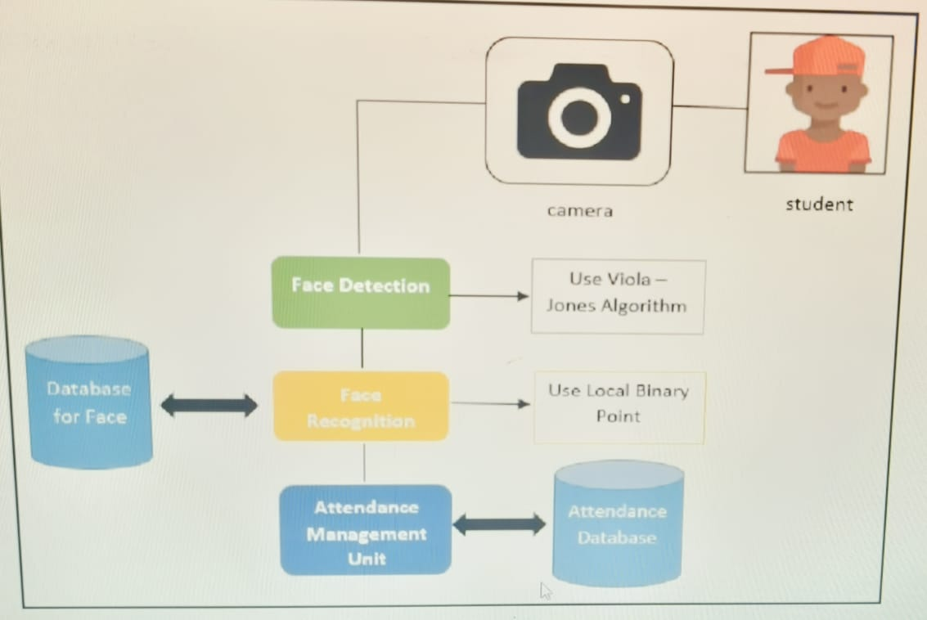

**3.2 Requirement Specification**

#### **1. Programming Languages:**

* **Python:** Primary language for developing the face recognition system and backend logic.
* **JavaScript:** For frontend development to enhance interactivity in the admin interface.

#### **2. Libraries and Frameworks:**

* **OpenCV:** For real-time image capture, face detection, and image processing.
* **Dlib:** For facial landmark detection and feature extraction.
* **TensorFlow/Keras:** For building and training the Convolutional Neural Network (CNN) used in face recognition.
* **Face Recognition Library:** A Python library for simplified face recognition tasks.
* **Flask/Django:** For developing the web-based backend interface and API integration.

#### **3. Database Technologies:**

* **MySQL/PostgreSQL:** For storing user information and attendance records in a structured format.
* **SQLite:** Lightweight, embedded database for local development and testing.

#### **4. Web Technologies:**

* **HTML/CSS:** For building and styling the frontend interface.
* **JavaScript (with frameworks like React or Vue.js):** For creating a dynamic and responsive admin interface.

#### **5. Hardware Requirements:**

* **Camera:** High-resolution webcams or IP cameras for capturing clear facial images.
* **Computer/Server:** System with sufficient CPU and GPU power to handle real-time processing (e.g., NVIDIA GPUs for model inference).
* **Storage Device:** For storing attendance records and facial data securely.

#### **6. Development Tools:**

* **Jupyter Notebook:** For prototyping and testing the face recognition models.
* **PyCharm/Visual Studio Code:** For writing and debugging code.
* **Git/GitHub:** For version control and collaborative development.

#### **7. Deployment Platforms:**

* **AWS (Amazon Web Services), Azure, or Google Cloud:** For cloud-based deployment and storage.
* **Docker:** For containerization and easy deployment across different environments.

#### **8. Security Measures:**

* **SSL/TLS:** To secure data transmission between the frontend, backend, and database.
* **Encryption Libraries (e.g., PyCrypto):** For encrypting sensitive biometric data.

#### **9. Additional Tools:**

* **Nginx/Apache:** For serving the web application.
* **Postman:** For API testing and debugging.
* **Anaconda:** For managing Python environments and dependencies.



**Hardware Requirements:**

#### **1. Camera:**

* **Type:** High-definition webcam or IP camera.
* **Resolution:** Minimum 720p (1280x720); ideally 1080p (1920x1080) or higher for better image quality.
* **Frame Rate:** 30 frames per second (fps) for smooth real-time capture.
* **Features:** Autofocus, low-light adaptability, and wide-angle lens for capturing multiple faces in group settings.

#### **2. Computer/Server:**

* **Processor (CPU):**
  + **For Development/Small-Scale Deployment:** Intel Core i5 or equivalent.
  + **For Large-Scale Deployment:** Intel Core i7, i9, or AMD Ryzen 7/9.
* **Graphics Processing Unit (GPU):**
  + **For Real-Time Processing:** NVIDIA GPU with CUDA support (e.g., NVIDIA GeForce GTX 1660, RTX 2060, or higher).
  + **For High-Performance Computing:** NVIDIA Tesla or Quadro series for more demanding tasks and large datasets.
* **RAM:**
  + **Minimum:** 8 GB.
  + **Recommended:** 16 GB or higher for smoother processing of multiple concurrent face recognition tasks.
* **Storage:**
  + **Type:** SSD (Solid State Drive) for faster data retrieval.
  + **Capacity:** Minimum 256 GB; recommended 512 GB or 1 TB for storing attendance records, images, and model data.
* **Operating System:**
  + Windows 10/11, macOS, or Linux (Ubuntu 18.04/20.04).

#### **3. Network Infrastructure:**

* **Internet Connection:**
  + **For Cloud-Based Deployment:** Stable broadband with at least 10 Mbps upload/download speed.
  + **For On-Premise Deployment:** Local area network (LAN) with gigabit speeds.
* **Router/Switch:** Gigabit-capable for handling multiple simultaneous connections.

#### **4. Display and Peripherals:**

* **Monitor:** Full HD (1920x1080) or higher resolution display for admin interface and real-time monitoring.
* **Keyboard and Mouse:** Standard input devices for system administration.
* **External Storage (Optional):** External hard drives for backups and additional storage needs.

#### **5. Power Supply and Backup:**

* **Uninterruptible Power Supply (UPS):** To prevent data loss and downtime during power failures.
  + 1. **Software Requirements:**
* **Python:** A versatile programming language widely used for data science, machine learning, and computer vision.
* **OpenCV:** An open-source computer vision library for real-time image and video processing.
* **TensorFlow/PyTorch:** Deep learning frameworks for building and training neural network models, especially CNNs.
* **NumPy:** A library for numerical operations, essential for working with arrays and matrices.
* **Pandas:** A data analysis and manipulation library for handling and processing data.

**CHAPTER 4**

**Implementation and Result**

* 1. **Snap Shots of Result:**

Kindly provide 2-3 Snapshots which showcase the results and output of your project and after keeping each snap explain the snapshot that what it is representing.

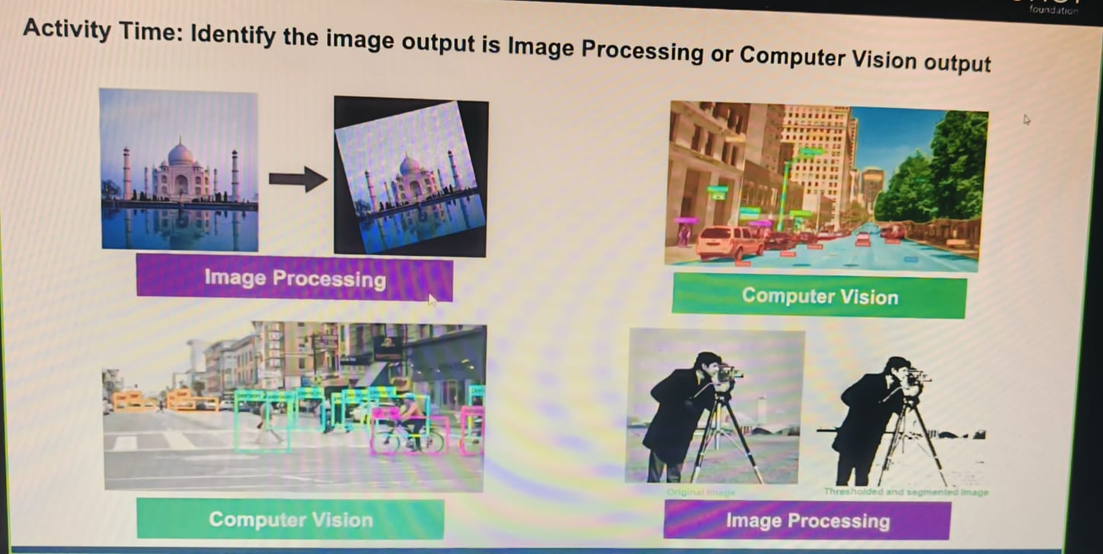

**4.2 GitHub Link for Code:**

[**https://github.com/vennelabontha/Attendence-Management-System-Using-Face-Recognition/**](https://github.com/vennelabontha/Attendence-Management-System-Using-Face-Recognition/)

**CHAPTER 5**

**Discussion and Conclusion**

* 1. **Future Work:**

### **Enhancing System Accuracy**

* **Facial Recognition Enhancements**:
  + **Improved Algorithms**: Integrate advanced deep learning models (e.g., CNN-based architectures like ResNet or Vision Transformers) for better accuracy in diverse lighting and angle conditions.
  + **Anti-Spoofing Mechanisms**: Implement liveness detection to prevent fraudulent attempts using photos or videos.
  + **Real-Time Performance**: Optimize models for faster inference to ensure real-time recognition.
* **Multi-Modal Authentication**:

Combine facial recognition with other biometric methods like fingerprint or voice recognition for added security and accuracy.

* **Error Correction Mechanisms**:

Introduce manual correction features to handle false positives or negatives, allowing admins to validate entries when discrepancies occur.

* 1. **Conclusion:**

The **Attendance Management System (AMS)** provides a reliable, efficient, and automated solution for tracking attendance in educational institutions or organizations. By leveraging advanced technologies like facial recognition, biometric authentication, and real-time data processing, the system minimizes manual effort, reduces errors, and prevents fraudulent practices.

**REFERENCES**

1. Ming-Hsuan Yang, David J. Kriegman, Narendra Ahuja, “Detecting Faces in Images: A Survey”, IEEE Transactions on Pattern Analysis and Machine Intelligence, Volume. 24, No. 1, 2002.